SCHOOLOFCOMPUTER SCIENCE AND ARTIFICIAL INTELLIGENCE |  |  |  |  | DEPARTMENTOFCOMPUTER SCIENCE ENGINEERING
Program Name: M. Tech/MCA/MSC |  |  |  | Assignment Type: Lab |  |  | AcademicYear:2025-2026
Course Coordinator Name |  |  |  | Venkataramana Veeramsetty
Course Code |  |  | 24CS002PC215 | Course Title |  | AI Assisted Problem Solving Using Python
Year/Sem |  |  | II/I | Regulation |  | R24
Date and Day  of Assignment |  |  | Week5- Tuesday | Time(s)
Duration |  |  | 2 Hours | Applicable to  Batches
AssignmentNumber:13.3(Presentassignmentnumber)/24(Totalnumberofassignments)
 | Q.No. | Question |  |  |  |  |  | ExpectedTime  to complete

 | 1 | Lab 13 – Code Refactoring: Improving Legacy Code with AI Suggestions  Lab Objectives  - To introduce the concept of code refactoring and why it matters (readability, maintainability, performance).  - To practice using AI tools for identifying and suggesting improvements in legacy code.  - To evaluate the before vs. after versions for clarity, performance, and correctness.  - To reinforce responsible AI-assisted coding practices (avoiding over-reliance, validating outputs).  Learning Outcomes  After completing this lab, students will be able to:  - Use AI to analyze and refactor poorly written Python code.  - Improve code readability, efficiency, and error handling.  - Document AI-suggested improvements through comments and explanations.  - Apply refactoring strategies without changing functionality.  - Critically reflect on AI’s refactoring suggestions.  Task Description #1 – Remove Repetition  Task: Provide AI with the following redundant code and ask it to refactor  Python Code  def calculate_area(shape, x, y=0):  if shape == "rectangle":  return x * y  elif shape == "square":  return x * x  elif shape == "circle":  return 3.14 * x * x  Expected Output  - Refactored version with dictionary-based dispatch or separate functions.  - Cleaner and modular design.  Prompt: Refactor the following Python code to remove repetition using a cleaner modular design or dictionary-based function dispatch: def calculate_area(shape, x, y=0): if shape=='rectangle': return x*y; elif shape=='square': return x*x; elif shape=='circle': return 3.14*x*x.  Code:  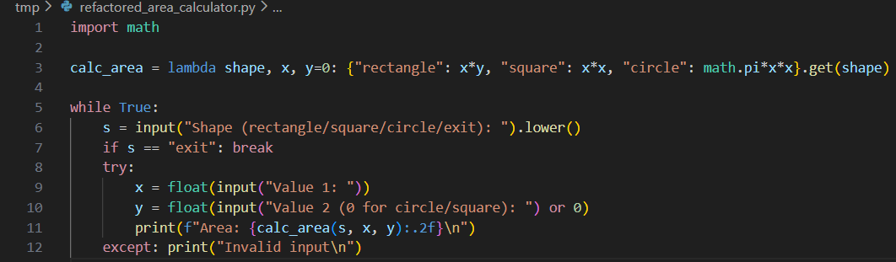  Code Explanation:  - A lambda function calc_area selects the formula based on the shape using a dictionary lookup.  - Rectangle uses x*y, square uses x², and circle uses πx² as their respective area formulas.  - User repeatedly enters a shape name, or types “exit” to stop the program.  - Inputs x and y are taken, where y is ignored (set to 0) for circle and square.  - The program prints the calculated area, and handles invalid inputs with an error message.  Output:  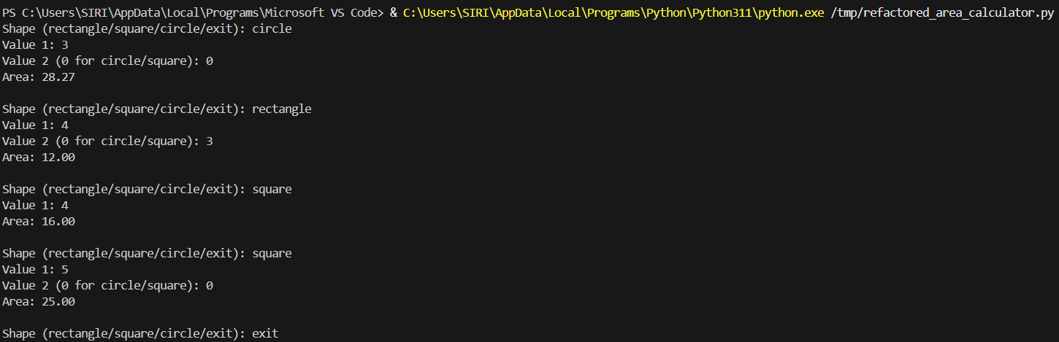  Task Description #2 – Error Handling in Legacy Code  Task: Legacy function without proper error handling  Python Code  def read_file(filename):  f = open(filename, "r")  data = f.read()  f.close()  return data  Expected Output:  AI refactors with with open() and try-except:  Prompt: Refactor the following legacy Python function to include proper error handling using with open() and try-except: def read_file(filename): f=open(filename,'r'); data=f.read(); f.close(); return data.  Code:  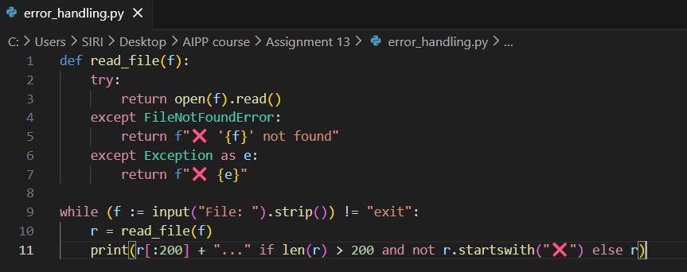  Code Explanation:  - read_file() tries to open and read a file, returning its full text if successful.  - If the file doesn’t exist, it returns a clear “file not found” error message.  - Any other exception (permission, encoding, etc.) is also caught and returned as a message.  - The main loop keeps asking for filenames, stopping only when the user types "exit".  - If the file content is very long, only the first 200 characters are shown, followed by “…”, unless it is an error message.  Output:  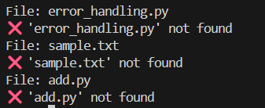  Task Description #3 – Complex Refactoring  Task: Provide this legacy class to AI for readability and modularity improvements:  Python Code  class Student:  def __init__(self, n, a, m1, m2, m3):  self.n = n  self.a = a  self.m1 = m1  self.m2 = m2  self.m3 = m3  def details(self):  print("Name:", self.n, "Age:", self.a)  def total(self):  return self.m1+self.m2+self.m3  Expected Output:  - AI improves naming (name, age, marks).  - Adds docstrings.  - Improves print readability.  - Possibly uses sum(self.marks) if marks stored in a list.  Prompt: Refactor the following legacy Python class to improve readability and modularity by using better variable names, adding docstrings, improving print formatting, and optionally storing marks in a list: class Student: def __init__(self,n,a,m1,m2,m3): self.n=n; self.a=a; self.m1=m1; self.m2=m2; self.m3=m3; def details(self): print('Name:',self.n,'Age:',self.a); def total(self): return self.m1+self.m2+self.m3.  Code:  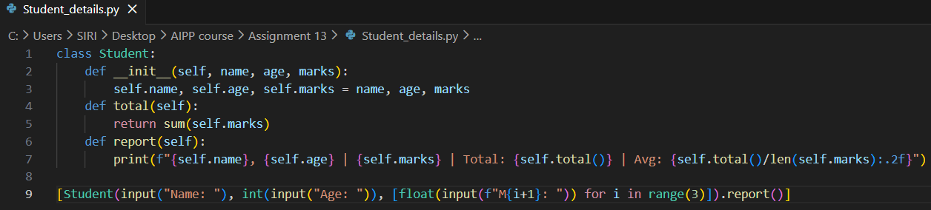  Code Explanation:  - Student stores name, age, and a list of marks given during object creation.  - total() returns the sum of all marks, making it easy to compute results.  - report() prints the student's details, including marks, total, and average.  - A single Student object is created using inputs for name, age, and three marks.  - The object’s report() method is immediately called, printing the student's full result summary.  Output:  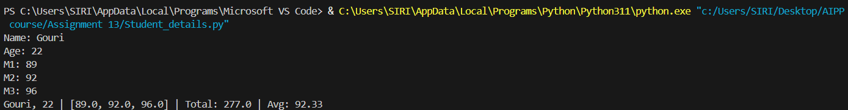  Task Description #4 – Inefficient Loop Refactoring  Task: Refactor this inefficient loop with AI help  Python Code  nums = [1,2,3,4,5,6,7,8,9,10]  squares = []  for i in nums:  squares.append(i * i)  Expected Output: AI suggested a list comprehension  Prompt: Refactor the following inefficient Python loop into a cleaner list comprehension: nums=[1,2,3,4,5,6,7,8,9,10]; squares=[]; for i in nums: squares.append(i*i).  Code:  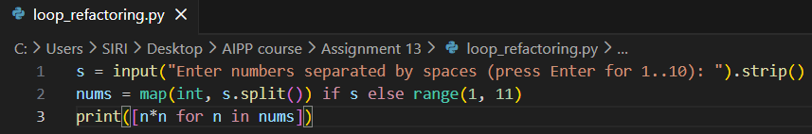  Code Explanation:  - User enters numbers, or if left empty, the code defaults to numbers 1 through 10.  - If input exists, it splits the string and converts each piece to an integer.  - If no input is given, range(1, 11) automatically becomes the number list.  - A list comprehension computes n*n, generating the square of each number.  - Finally, the list of squared values is printed as the output.  Output: | Week5- Tuesday

